**Projects ideas II**

**1-**There is a data frame regarding SAMSUNG stock price from 2000 to 2022. This is the 5 rows of this data frame:

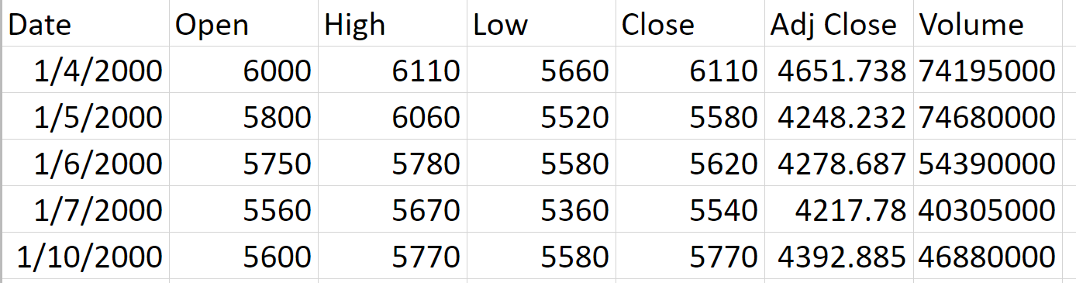

The table has 5621 rows and it includes these columns:

Date, Open, High, Low, Close, Adj Close, Volume.

The price unit of the stock is in Korean Won (KRW)

According to the dataset, what is the high price of the stock for years 2015-2022?

**2-**There is a table related to top movies. This table contains movies from 1940 to 2021. Five rows of the table are here:

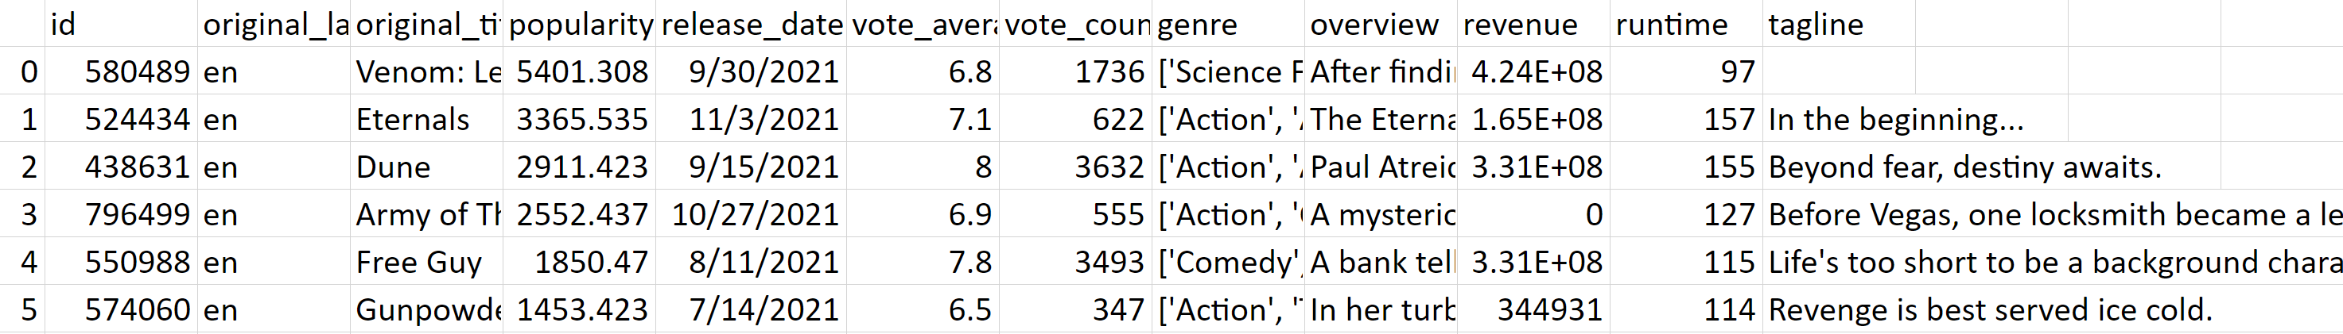

This data frame has 10000 rows and it includes these following columns:

Id, original language, original title, popularity, release_date, vote_average, vote_count, genre, overview, revue, runtime and tagline.

For movies in year 2022, based on movie description what is the genre of the movie?

**3-**Statistical values for weather conditions of Austin, Texas in the United States have been collected from 2013 to 2017. The table includes 1320 rows and 20 columns. The first five rows of the data frame are here:



What are the average temperature and humidity for last 21 days of the year 2017?